Programming Assignment
The 'priority queue' abstract data type

CPS1000
Programming Principles in C
Instructor: Mark J. Vella

Linux Mint Debian Edition

Stefan Mallia
0128591m
Bachelor of Science (Honours)
Computing Science
and
Statistics and Operations Research



University of Malta
Department of Computer Science

Data Structures

The Array
An array is a data structure which stores multiple elements in a single variable. The elements in an array are usually of the same type but some languages allow the user to store different data types in a single array.

The concept of an array is that of a linear storage of information with a specified length. Often the way an array is stored in hardware is also linear.

Arrays can be multidimensional with no limit on the number of dimensions possible. Figure 1 is an illustration of a simple one-dimensional array and also of a two-dimensional array. Also shown in Figure 1 are the index numbers used to access a particular element from an array. Programming languages usually start their index from 0 and continue to n-1 as shown; this is the case for C where array index are appended to the variable within square brackets [ ]. To represent more than one dimension multiple square brackets can be used next to each other [ ][ ].

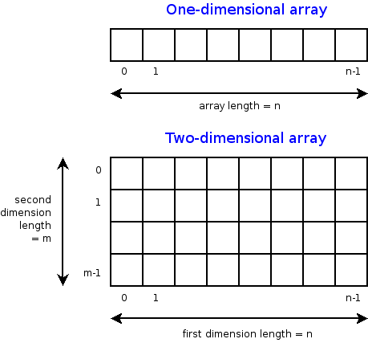
Figure 11

Circular/Ring Buffer
A circular buffer is a memory allocation approach where memeory is recycled when an incremental index reaches a limit. It is conceptually similar to a simple array but with the difference that both ends of the array are connected to each other to form a circle.

This assignment's implemented ring buffer reserves n elements but only allows n-1 to be used. This is done so that the recognition between an empty queue and a full queue is made easier. In this manner an empty queue can be identified when the start and end indicators point to the same node and a full queue can be identified when the start indicator points to node 0 and the end indicator points to node n-1.

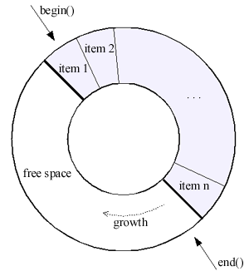
The end indicator points to the next node where data is to be written. Both the start and end indicators are shifted forward by one when the node at index n-1 (last node, meaning that queue is already full) is written over. This means the information at node n-1 is never used. An illustration of a cicular buffer is shown in Figure 2.

Figure 22

Linked List
A linked list is a data structure which consists of nodes which form a sequence. Each node is split into two parts: the element data that the node contains and a pointer to the address of the next node in memory.

Unlike the circular buffer this is a dynamically allocated data structure, meaning that the number of nodes allocated to memory is equal to the amount of elements stored. The list can then shrink or grow as needed during run time. While this is an efficient way of storing information in memory ( especially when the list has the potential to grow very large), it comes with the draw back of being less efficient than the circular buffer when it comes to accessing elements from the queue. To access an element in a linked list, each element must be iterated through until the desired element is found. Figure 3 shows an illustration of a linked list.

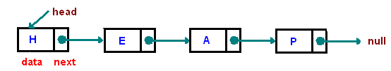

Figure 33

Binary Heap
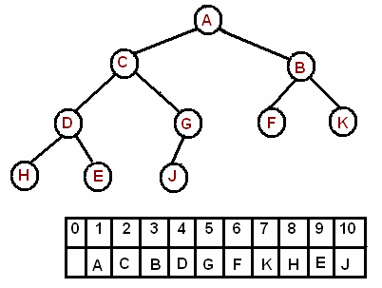
A data structure that stores data in the form of a binary tree. A representation of a binary heap is shown in Figure 4.

Figure 44
References

http://en.wikibooks.org/wiki/Data_Structures/Arrays
http://ycpcs.github.io/cs201-summer2014/notes/javaArrays.html
http://c2.com/cgi/wiki?CircularBuffer
http://www.c4learn.com/data-structure/introduction-to-linked-list-c-programming/
http://www.cs.cmu.edu/~adamchik/15-121/lectures/Linked%20Lists/linked%20lists.html
http://cslibrary.stanford.edu/103/LinkedListBasics.pdf
http://www.cs.cmu.edu/~adamchik/15-121/lectures/Binary%20Heaps/heaps.html

1 Source: http://ycpcs.github.io/cs201-summer2014/notes/javaArrays.html
2 Source: http://www.boost.org/doc/libs/1_39_0/libs/circular_buffer/doc/circular_buffer.html
3 Source: http://www.cs.cmu.edu/~adamchik/15-121/lectures/Linked%20Lists/linked%20lists.html
4 Source: http://www.cs.cmu.edu/~adamchik/15-121/lectures/Binary%20Heaps/heaps.html

